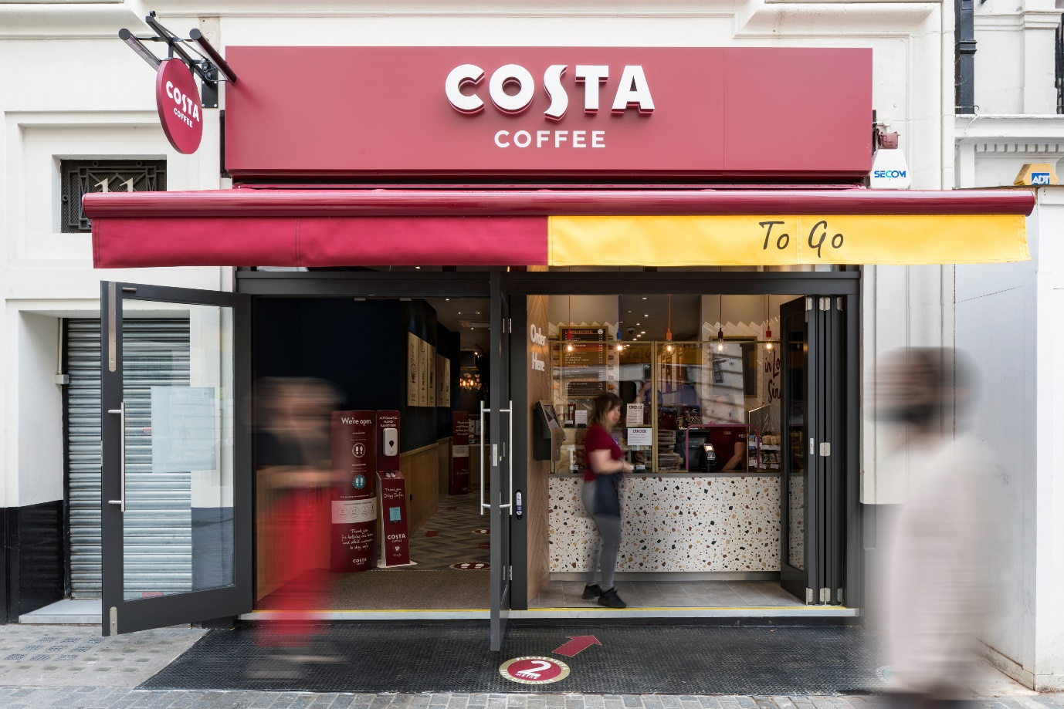
Costa Coffee Crowned the Nation’s Favourite Coffee Shop for the 11th Year Running
In a survey of more than 5,000 UK consumers, Allegra asked the Great British Public to name their favourite coffee shop, the results were unanimous – Costa Coffee has taken the top spot again – sealing more than a decade as the UK’s preferred high street pick-me-up
During an incredibly challenging 12 months for hospitality businesses everywhere, Costa Coffee has stepped up to the task of quenching the UK’s thirst for coffee and café culture. In doing so it has continued to capture the hearts and minds of the Great British Public to retain its place as The Nation’s Favourite coffee shop* for the 11th consecutive year.
Keeping the nation caffeinated
More than half of UK consumers surveyed by Allegra choose their coffee shop based on the effectiveness of their Covid-19 safety measures. With contactless payment, social distancing markers and hand sanitising points cited as key concerns, Costa Coffee has championed operational safety by deploying all of these features nationwide.
Covid-19 has introducing new routines and shopping habits for us all, and Costa Coffee has risen to the challenge of reaching customers whenever and wherever they need. The coffee chain has tapped into growing market potential for food and beverage delivery to reach customers nationwide and introduced bespoke contactless serving hatches at drive-thru locations.
Meanwhile, as the UK at-home coffee market booms during Covid-19, Costa Coffee’s at-home and Ready-To-Drink range, available within supermarkets nationwide reflects of a new era of
UK coffee shop brand engagement in the at-home coffee segment.
Staying safe, staying sustainable
The fight against Covid-19 shouldn't mean a setback for sustainability at UK coffee shops. With Allegra research showing consumer awareness of disposable cup waste growing year-on-year, in late 2020 Costa Coffee introduced an innovative anti-bacterial Reusable Cup Lid so customers can continue caring for the environment while keeping Covid-safe.
Looking to the year ahead, in 2021 the UK’s favourite coffee chain stepped up its efforts to combat food waste, expanding its partnership with the number one anti-food-waste app, Too Good To Go, with the offering now available at 1,100+ participating UK stores.
Commenting on the accolade, Allegra Group Founder & CEO Jeffrey Young said:
“During an incredibly challenging year for UK coffee shops grappling with Covid-19 it is encouraging to see strong UK players, such as Costa Coffee, continuing to capture the hearts and minds of British coffee drinkers.
“I’d like to extend my congratulations to the entire Costa Coffee team for their hard work and determination in securing the title of The Nation’s Favourite coffee shop for the eleventh year in a row.”
Costa Coffee Managing Director UK&I Neil Lake said:
“As we celebrate our 50th Birthday this year, we are delighted to have been voted the nation’s favourite coffee shop for the eleventh consecutive year. After an extremely challenging 2020 this accolade, voted for by consumers, is truly humbling and a testament to the support and hard work of our talented baristas, our longstanding franchisees, partners and suppliers and all our Costa colleagues. The safety of our teams and customers has always been our number one priority and we have worked hard to ensure we can continue to safely serve customers their favourite Costa coffee, in line with Government guidelines. Despite the pandemic we continue to invest to grow and innovate, launching a fantastic co-branded Christmas range and most recently our Latte+ range. As the nation’s favourite we remain committed to our communities and supporting those at the forefront of the pandemic, launching ‘Costa With You’, giving away over a million free hot coffees and Ready-To-Drink coffee cans.
We look forward to safely celebrating our 50th Birthday with our teams and customers in person – serving more cups of great coffee, to more people, more often.”

